So with that done our player , our ground and our background is ready. Now we need to set up our obstacles
For that we have something called Crate in our project panel inside Assets>Sprite
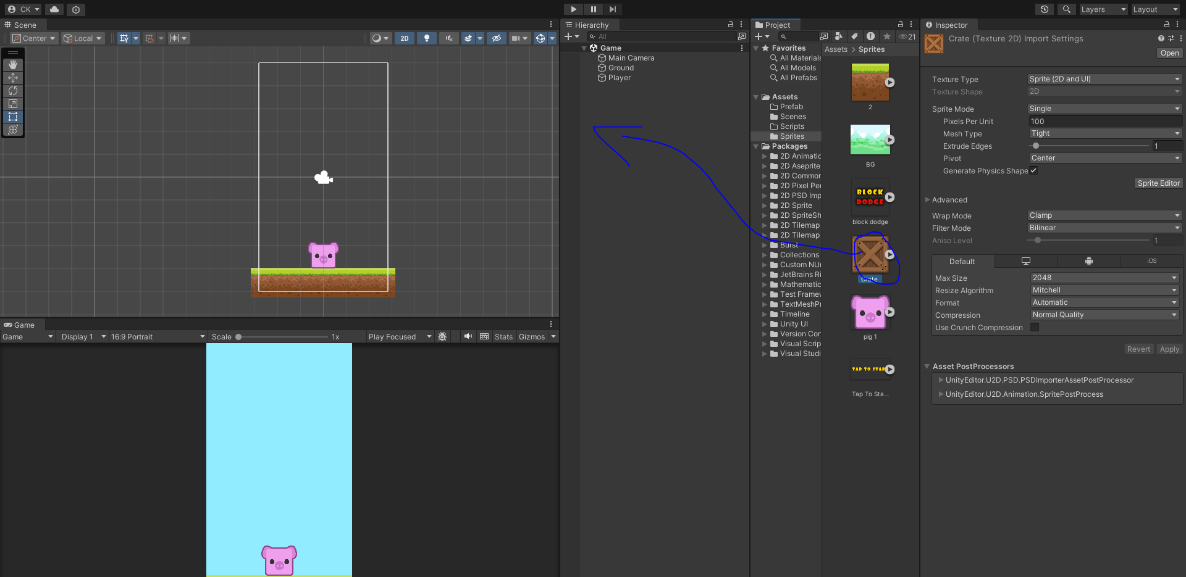
Now we drag and drop this crate to our Heirarchy or you can put it inside
Now we will rename it to block
Now we are going to add Rigidbody2D component to our block IOA(instance of Assets) in Heirarchy panel
and then we will add BoxCollider2D component to it.
And now we are going to add tag to our block (which i think is a unique nickname given to that IOA which we can use in coding of our game for its identification)

So for that go to inspector panel of Block IOA
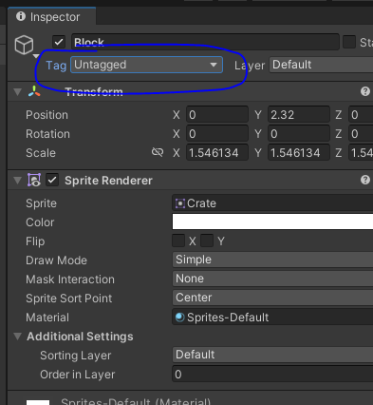
and then click on marked area above a submenu will open like below
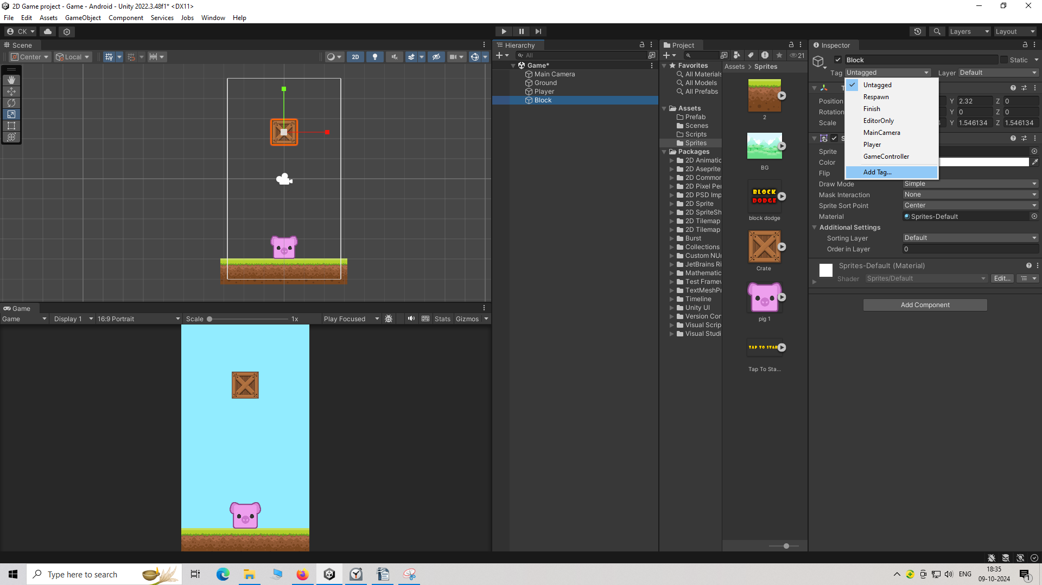
and then click on Add tag.
Snd now inspector will look like below
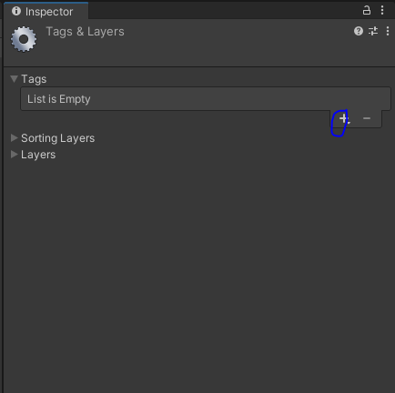
and now click on marked + button then a new mini window wil be opened like below
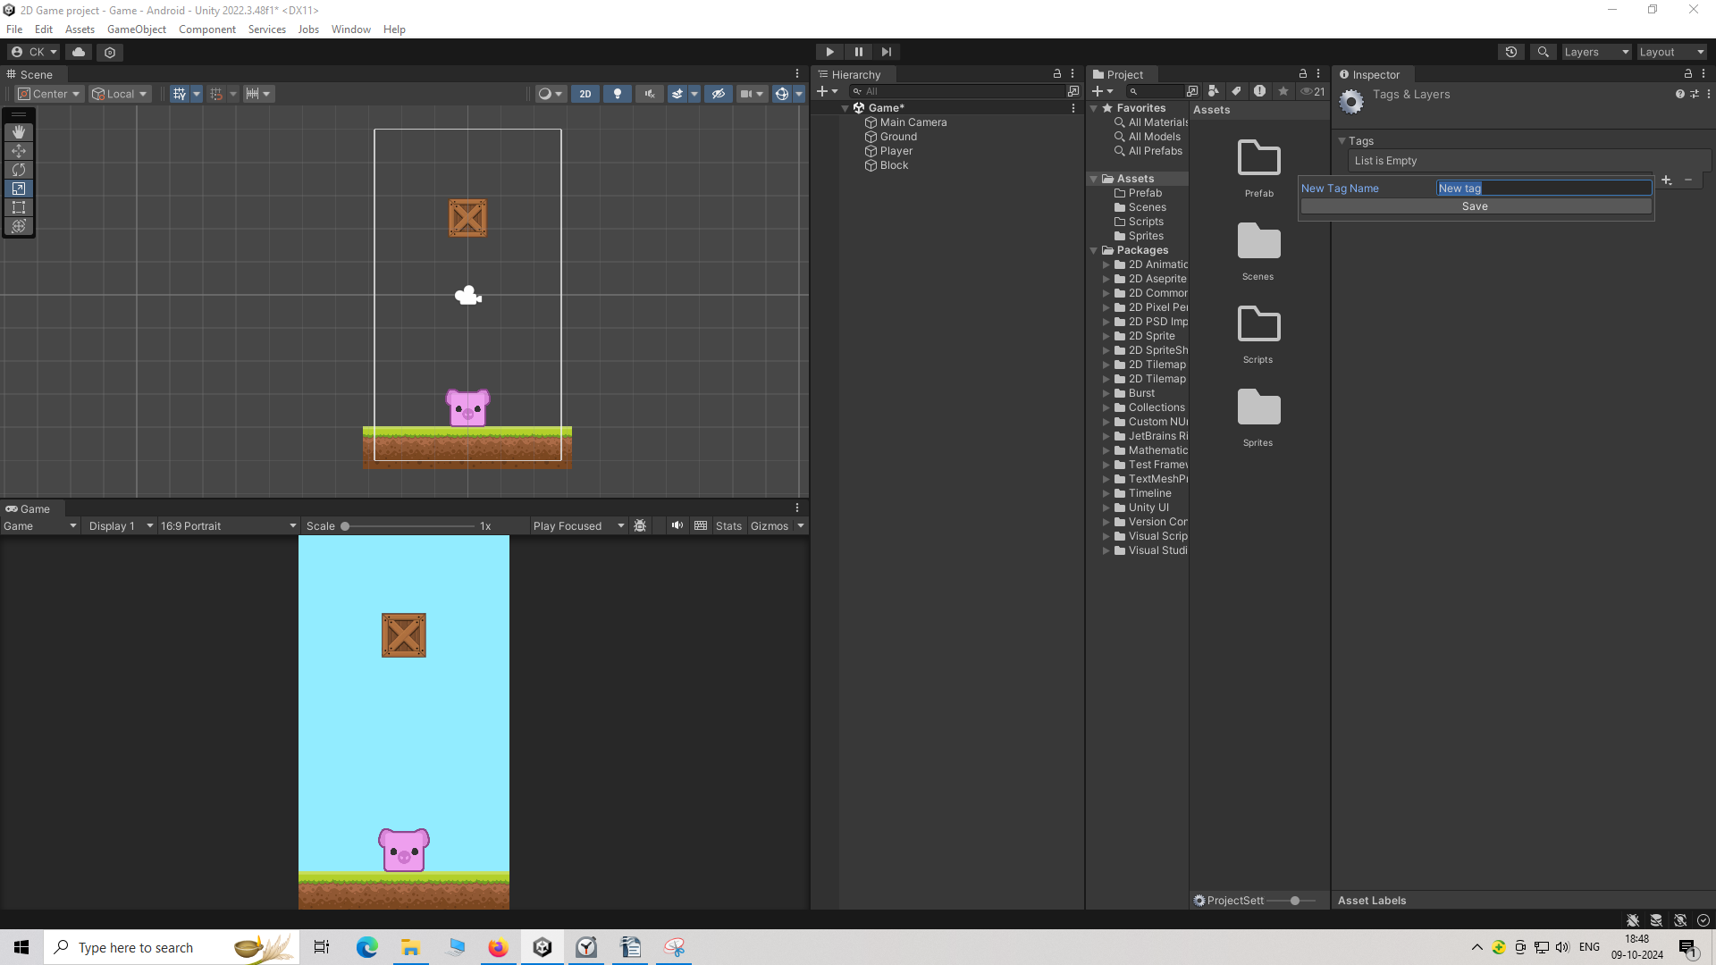
Now in that temporary mini window textfield type the name of the tag you want to create and then click on Save button below the textfield to save this tag
and then the inspector panel you will see that tag listed as marked below
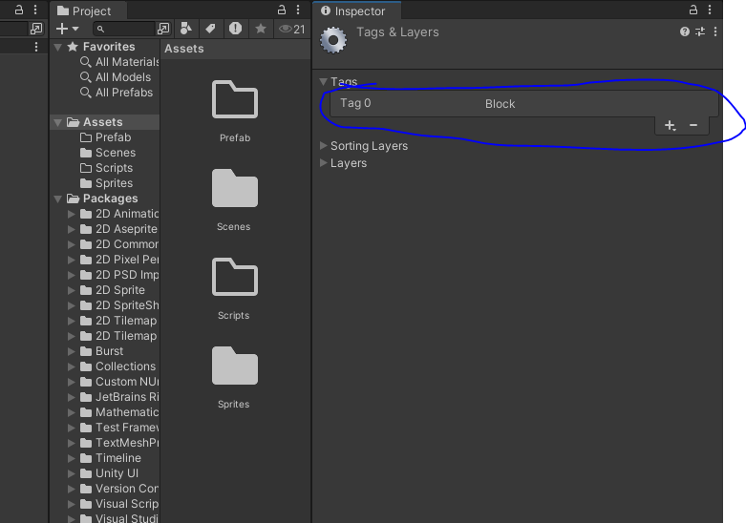
Now again click on Block assets and then go to inspector panel
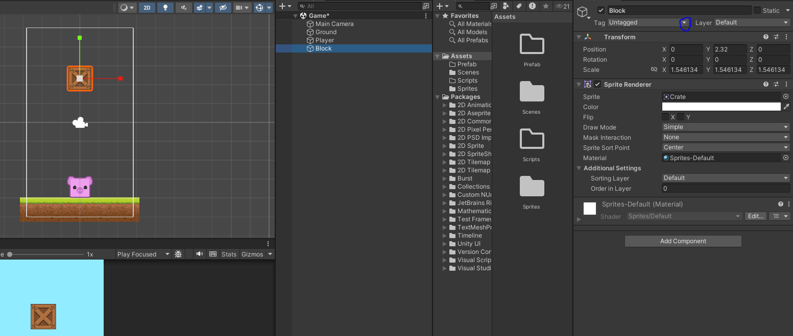
and now click on marked button above and then you will be presented a submenu and in that submenu choose Block tag that we had created
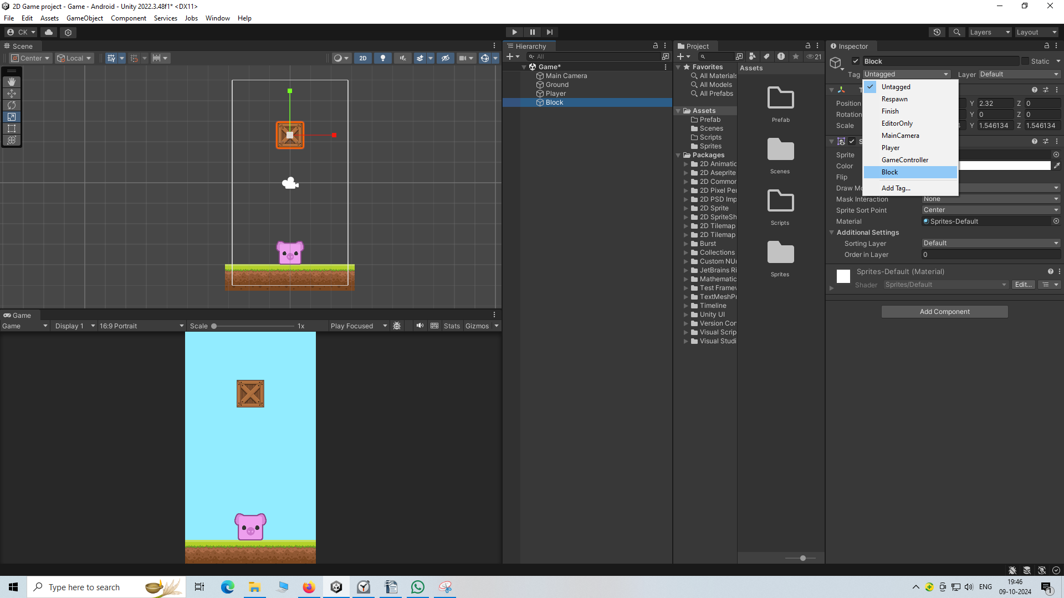
Now our box has Boxcollidor2D, Rigidbody2D so add them to our box and also a block tag attached to it.
So our player and block is ready now when you will play you will see that
The block is falling downward due to gravity. And it immediately sits above the player as they both have box collidor
but whwn you move the block in left direction so that it does not collide with player while it is falling down it falls down and dissapears doen the game panel.
So our Block is ready and Player is ready.

